DAY-03 TASK

The Author component is created in cruxde lite as their path is like

App/myTraining/components/author

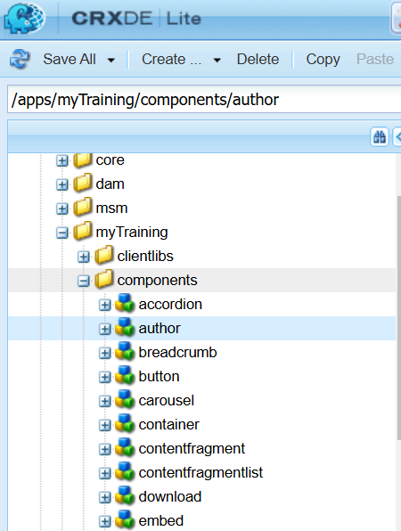

With their properties as

The dialog consists of three mandatory fields:  
 **Author Name** - Single-line text field  
 **Author Bio** - Multi-line text field  
 **DOB** - Date picker

Path: **/apps/myTraining/components/author/cq:dialog**

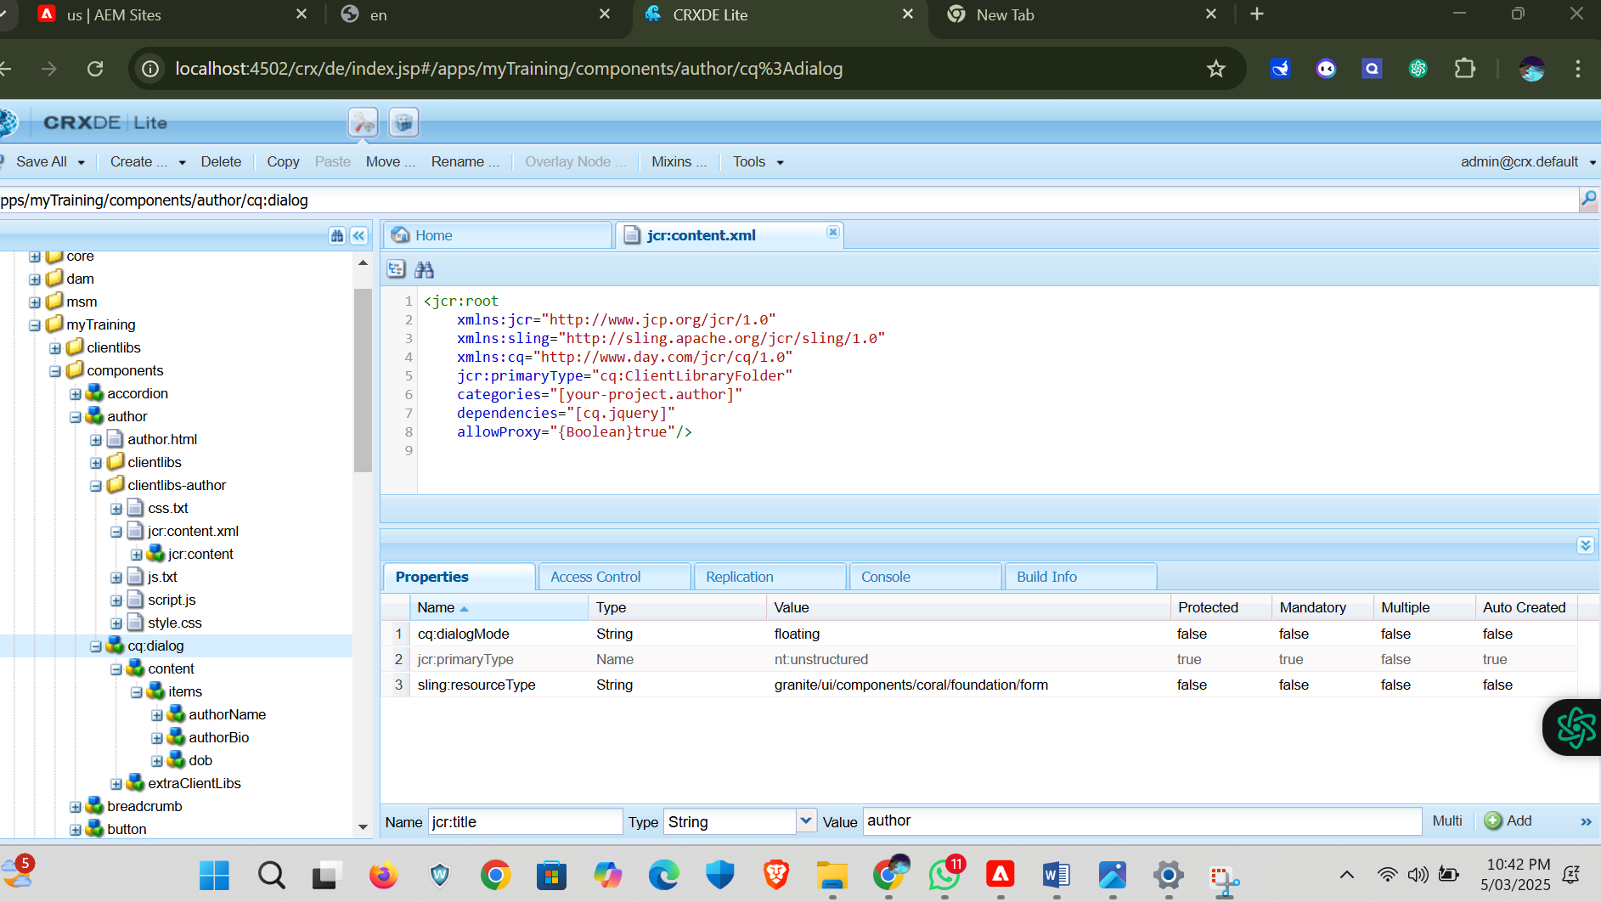

**Fetching Values in HTL**

The values are displayed using **HTL properties** in author.html:

<div class="author-container">

<h1>${properties.authorName}</h1>

<p>${properties.authorBio}</p>

<strong>${properties.dob}</strong>

</div>

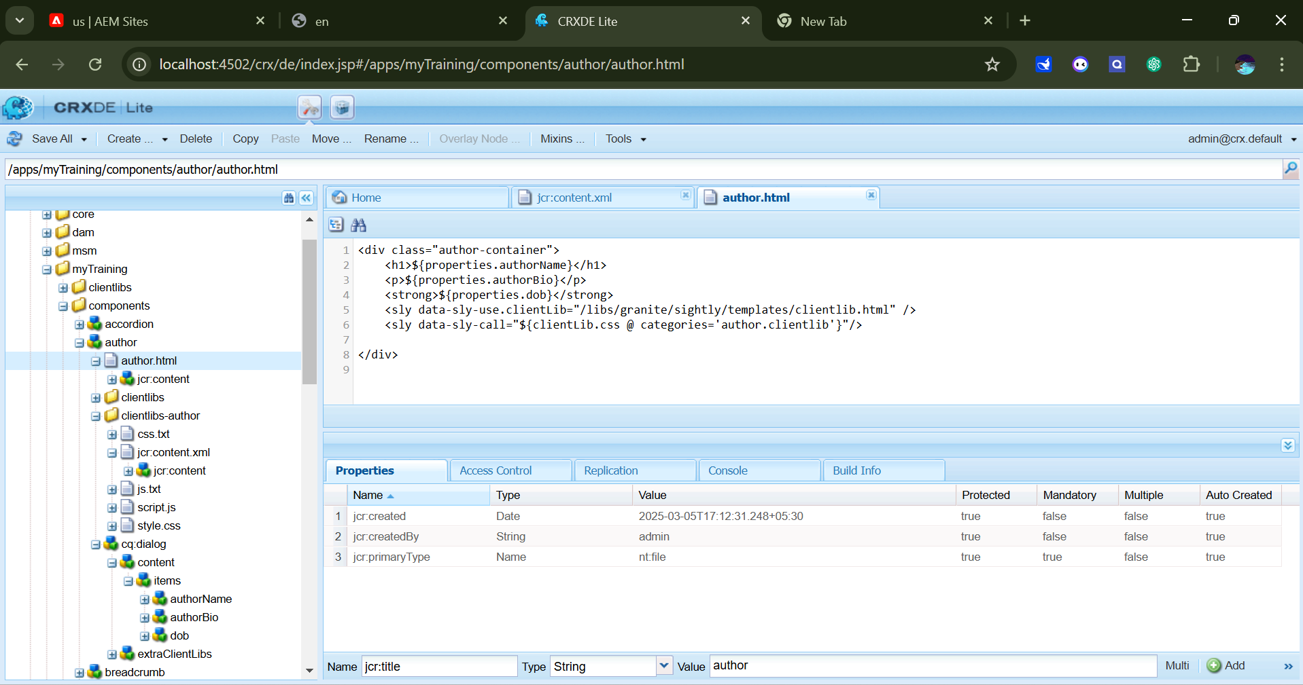

We have to properties for each items

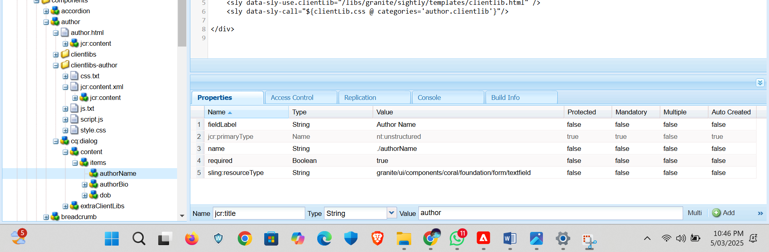

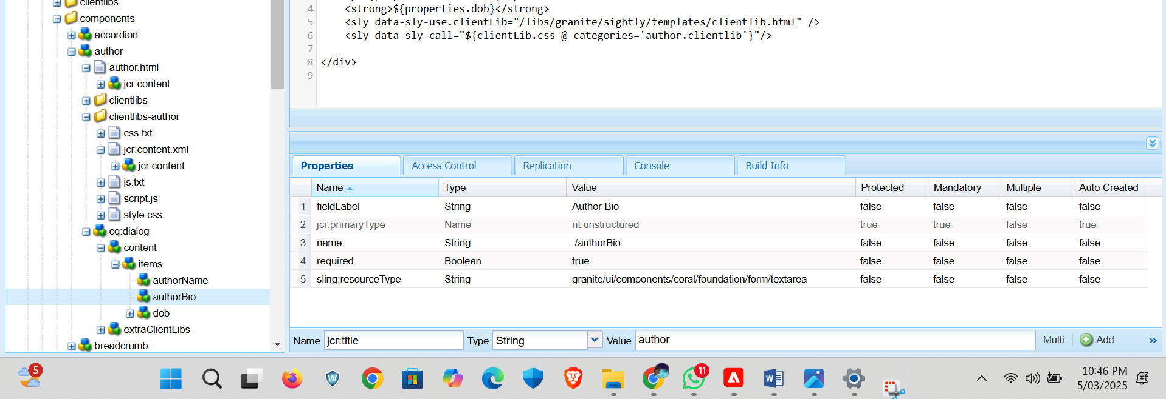

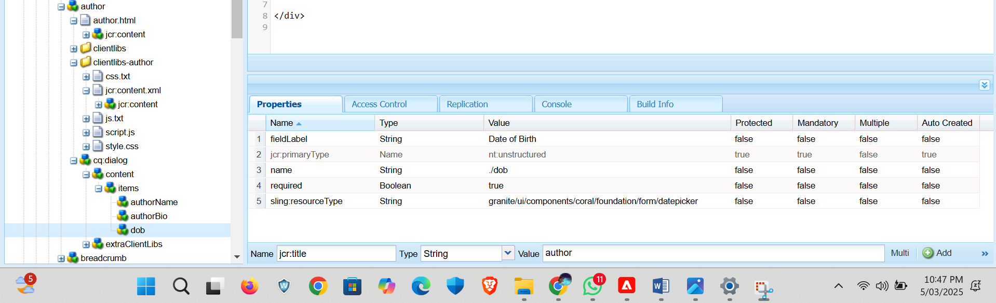

ClientLib in AEM

Client libraries (ClientLibs) store CSS, JS, and other front-end assets for an AEM component.They ensure faster loading and better modular management.

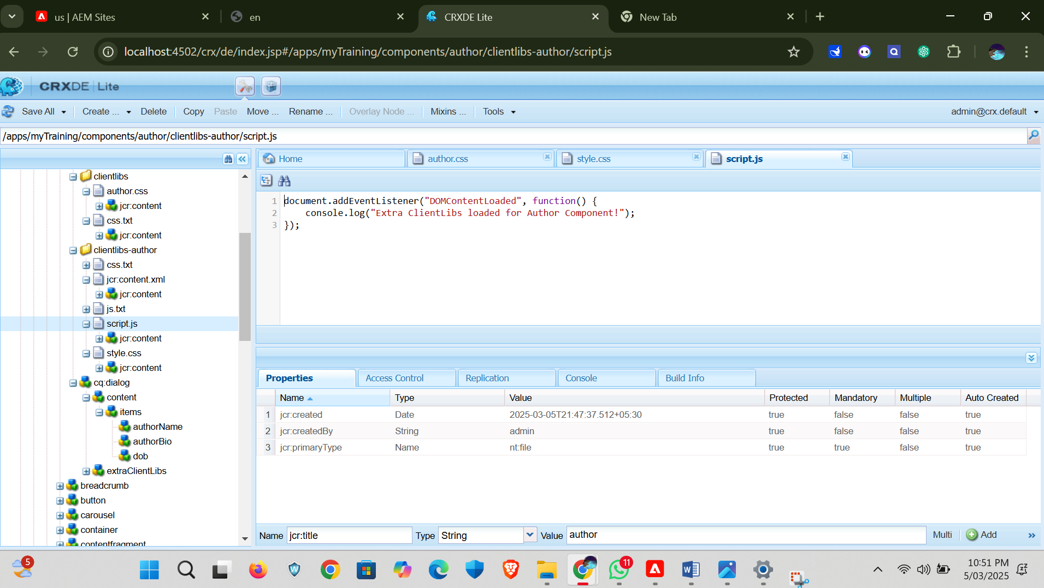

After saving it all to check for output we need goes to http://localhost:4502/editor.html/content/myTraining/us.html and select the project and click edit and navigate to editable page where there are list of components are there. Select the component it navigate to input dialog box and produce output.

